**FABRIC AND WINDOW TREATMENTS**

**IDEC1045**

**WEEK 3, Weaves, patterns and finishes**

1. Replace the highlighted areas above.
2. Fill in the cells on the right in the table below.

## Week at a Glance

|  |  |
| --- | --- |
| **Week at a Glance** | |
| This week’s course learning outcomes (number and text) | **CLO02:**  Evaluate fabric construction that include weaves, yarns and durability for various window treatment trends. |
| This week’s unit learning outcomes (number and text) | **Text:** Designing Interiors page 411, 414-419  **Unit 1:**  1.3 Outline fabric construction such as yarns and weaves  1.4 Outline fabric finishing techniques such as soil resistance and decorative finishes  **Unit 2:**  2.4 Discuss fabric weights and their uses in home decor |
|  | |
| This week’s problem | This week’s problem is to understand that there are different kinds of weaves in fabric construction and finishing techniques to give fabrics their appearance, durability and usefulness in various window treatments. We will also look at fabric weights and what are appropriate for certain kinds of window treatments. This is important for the student to know when determining what kind of fabric is suitable for a certain room, kind of window treatment and client needs. |
| How does this week’s problem fit into the course so far? | This week is a continuation of the past lesson and begins to build on the student knowledge of fabric. It will become the basics of what kind of material they will choose for a certain window treatment use, durability and successful window treatment for a client. |
| List of topics and subtopics that will be covered to address this week’s problem | **Importance of Fabrics**  **Weaves:** plain, satin, twill, complex. Fabric blends  **Fabric finishing:** functional and decorative finishes  **Patterns:** kinds of plaids, geometric, stripes, floral, mixing patterns in one treatment etc.  **Fabric weights:** heavy, medium and light |
| If this is a hybrid course, what topics and activities will be covered in-class to support the online content? |  |
| How does problem fit into the remaining weeks of the course? | This week gives the student a better understanding of fabric differences, weaves and construction to select an appropriate fabric use for a specific kind of window treatment |
|  | |
| Graded Assessment? | Yes. Fill out the Evaluation section below.  No. |

## Introduction

|  |  |
| --- | --- |
| **Introduction to Week** | |
| Introduction | Description of content for this week:   * Explain what the user will learn * Describe the problem the user will be able to solve by the end of week * Answer the question “What’s in it for me (the learner)?”   Most people know little about fabrics other than how they look. This week we will look into more detail about all kinds of fabric to understand that there are different kinds of weaves that produce a certain look in window fabric. We will discover some fabric finishes that are applied at the manufacturing level to enhance materials and learn about the different fabric weights and how they can be used in certain window treatments. We will also go over some important terminology that is used in the window treatment industry that is important to recognize. All of this information will give you more knowledge into the world of retail fabric and allow you to select with more skill what kind of fabric will suit various window treatments. |
| Learning Outcomes | Write out the week’s unit learning outcomes here (number and text).  **Text:** Designing Interiors page 411, 414-419  **Unit 1:**  1.3 Outline fabric construction such as yarns and weaves  1.4 Outline fabric finishing techniques such as soil resistance and decorative finishes  **Unit 2:**  2.4 Discuss fabric weights and their uses in home decor |
| Other relevant announcements/ reminders | Insert notes on assignments and/or anything out of the ordinary.  Note: You can also add an image here for a front cover page look and feel.  C:\Users\Linda\Downloads\521812220.jpg Istock id:521812220 |

****************** Beginning of instructional content ************************

# Importance of fabrics:

Fabrics are used by everyone all over the world on a daily basis. We often take them for granted without thinking much about them, where they come from, kind of material or what they are called. As a decorator it is important to have a basic understanding of all kinds of fabrics, their pros and cons, uses and how they will work in various window treatments in our homes. There are many things to consider when selecting window treatments and the fabric you select to use. Having a basic knowledge of different weaves, finishes and patterns will help you choose the right fabric for the right window treatment.

## Fabric blends:

Mixing or blending different fiber content is quite common for window treatments and can give positive qualities of each kind of fiber to improve an end result. It is also used to sometimes same on the cost. Many of today’s fabrics blend to increase durability or enhance visual appeal or to improve the dying quality of a fabric. Even 5-10% fiber blend can make a little difference in the functioning of a fabric. For example, polyester is often added to cotton for a more wrinkle free and soil resistant material as well as adding strength. Nylon added to wool can increase its strength. Cotton added to wool will not let it shrink or mat as easily and Acetate added to a fabric can add sheen.

Weaves:

Fabric weaving is a combination of a warp and a weft yarn being woven together to make a cloth. Weaving has many options to give different appearances to cloth.

Cloth can be open, semi-open and closed weave. The more open the weave the farther apart the warp and weft are from each other. In an open weave the warp and weft do not touch leaving gaps between the yarns. A semi-open is a tighter weave with the yarns closer together and a closed weave is when the yarn is directly touching each other. The tighter the weave the more stable the cloth is.

### Basic weaves:

**Plain weave** is also known as taffeta or tabby weave where each weft yarn goes over and under each warm yarn. This is the simplest and most common kind of weave and represents about 70% of all woven fabric worldwide.

Istock id: 644165862

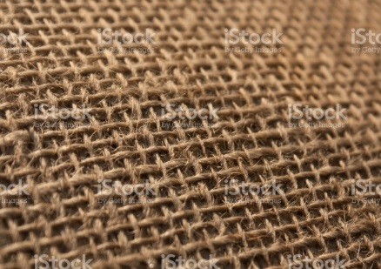 This is a semi-open plain weave

The **satin weave** has a surface that is mostly warp yarn showing. This weave creates a smooth surface by the warp passing over and under all but 1 weft yarn that intersects in a regular or irregular formation.

Insert photo 92256393

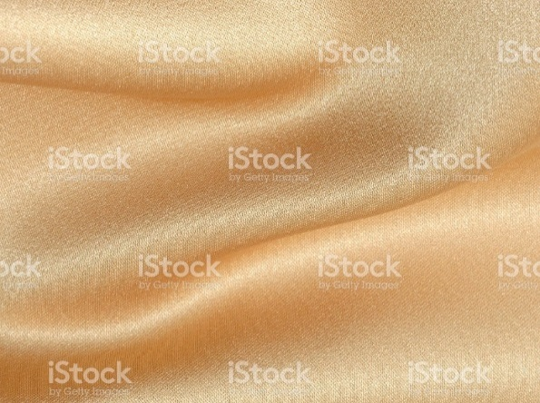 This smooth looking weave is called a satin weave

A **twill weave** is recognized when the weft yarn passes over two or more warp yarns. You can find this weave in denim and creates a diagonal line called a wale.

Istock id: 145907867

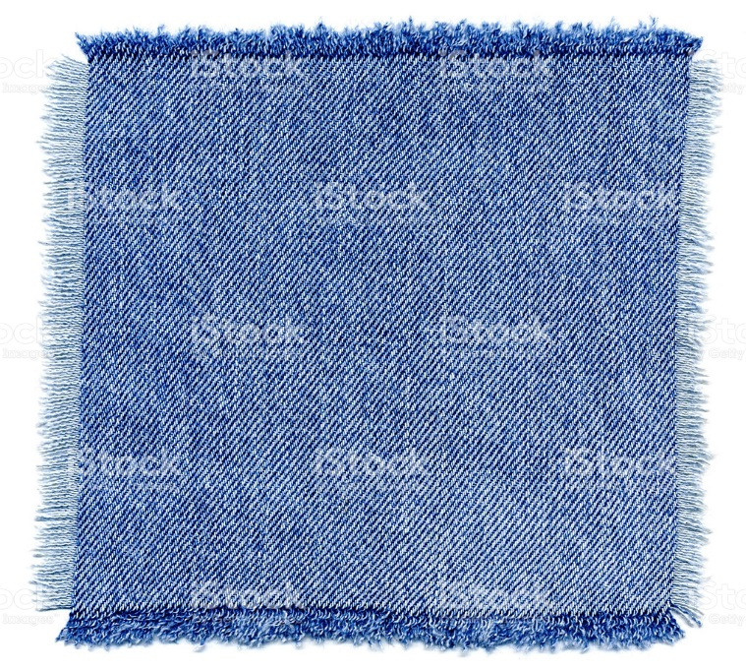Notice the diagonal line in this twill weave denim

Complex weaveshave many kinds of weaves in this category and are more complex than the three basic kinds of weave. There are many kinds of complex weaves and some of the most common for window treatments are described here.

**Jacquard** is a name of a weave that comes from the Jacquard loom attachment invented in the early 1800’s. Originally it was a punch card system that had a pattern on it and was a forerunner of early computers. It gave the loom automatic control of raising warp yarns and allowed the loom to make any design no matter how intricate. Today Jacquard weaves are made with CAD design computers.

Istock id: 176011920

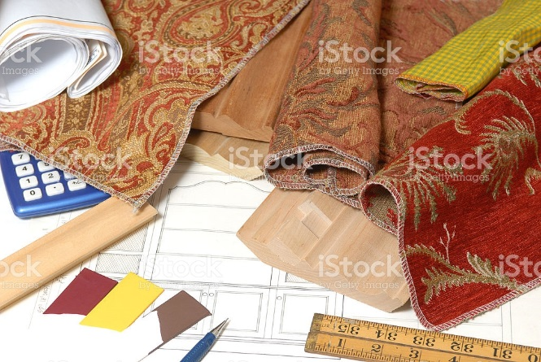 The fabrics shown here with their intricate patterns are called Jacquard weaves.

This is an interesting website about the Jacquard loom…

<https://en.wikipedia.org/wiki/Jacquard_loom>

**Basket weave** is a variation of the plain weave using two or more warp yarn crossing alternately side by side with two or more weft yarns to create a checkerboard pattern

Istock id: 465687885

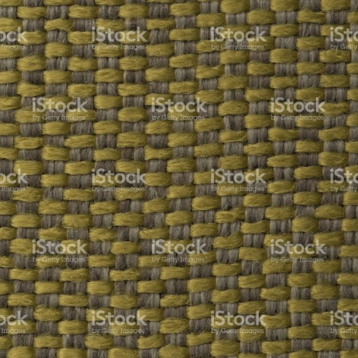

**Rib weave** is created by using thicker weft yarns creating a raised row look.

Istock id: 628608000

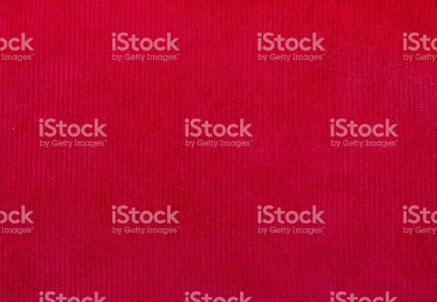 This rib weave shows the raised look with the use of a thicker weft yarn.

**Dobby weave** is the creation of small geometric pattern repeated over a cloth. Usually it has a slightly raised pattern to create a kind of pebble surface

Istock id: 6417880062

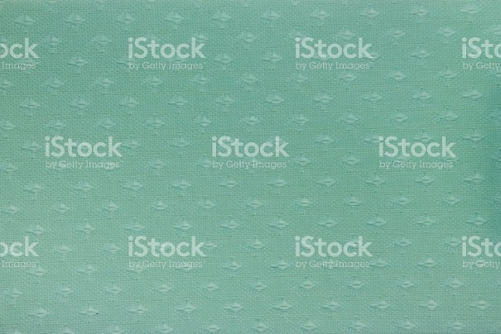 Notice the geometric pattern woven into this fabric

**Pile weave** is a 3D effect on the fabric that can be uncut like loops (velvet) or cut for a plush look (velour). This is created by adding an extra set of warp and weft yarn into the basic structure of the fabric.

Istock id: 157586922

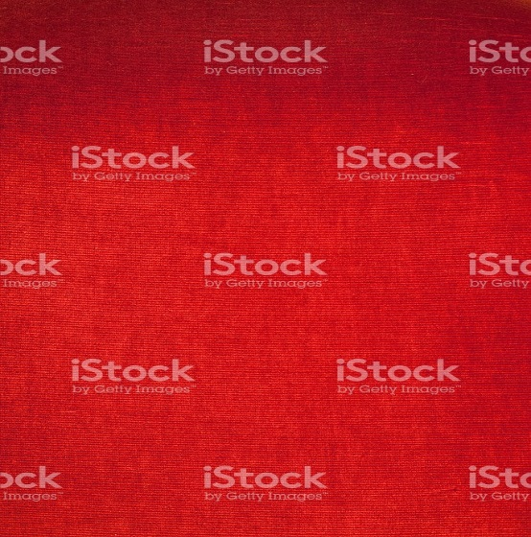 This is a velvet uncut pile

Istock id: 638615190

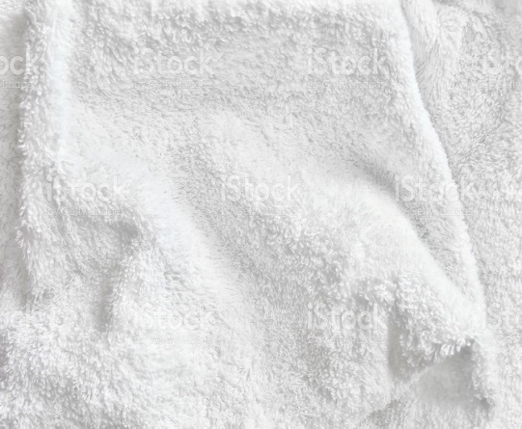 This is a cut pile velour

**Surface figure weaves** allow the base cloth to have extra yarns woven in to create a surface texture like a Swiss dot or a Lappet weave.

Fabric finishing:

While you may not readily recognize fabric finishing techniques when viewing or feeling a material, it is important to understand that there are many treatments that can be applied to fabric once it is produced. There is a lot that goes into making a fabric for retail use that can enhance the look, durability and even cost of a material you use in your home.

There are two basic kinds of finishing techniques applied after the production of the fiber.

**1. Functional finishing:**

Functional finishing can enhance durability and the ability to allow the fabric perform in a certain way. There are many kinds of functional finishing techniques and the following are some examples…

**Antibacterial treatments** are used to suppress mold and often used in health care

**Antistatic treatments** are applied to reduce static and soiling

**Flame and fire resistance** is applied to hospitality industry use and often children’s fabrics

Insulation is a foam product sprayed to the back of a fabric to improve temperature and reduce noise

**Fabric care** can be applied to make a fabric perma-press or wrinkle resistant

**Lamination** is the joining of two fabrics together such as a vinyl laminated to a knit backing often used in upholstery or sometimes on window treatments that have a vinyl backing.

**Soil repellent treatments** protect from dirt and stains

**Water repellent techniques** are added to fibers to allow less water absorption. Many fabrics have this treatment even though they may not be advertised. Some furniture stores offer this kind of after-market purchase.

**Istock id: 185317059**

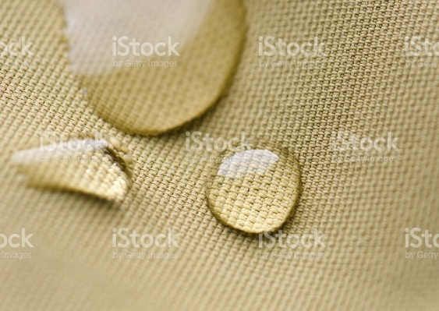

**Interesting note:** You can test a fabric with a couple of drops of water placed on the fabric. If it beads up like shown in the photo, it has this treatment applied and you may not need to purchase an added water repellent application. Also note that any treatment you apply after-market removes the fabric warranty from the manufacturer!

**Brightening** is a treatment that makes colours last longer

**Chintz** is a glaze that is added to a fabric to give it sheen. You often see this in cotton print fabrics. The glaze can be rubbed off on lesser quality fabrics while some glazes can be permanent on others.

**Anti-wrinkling** is used to retain a fabric shape and not allow it to wrinkle

**Abrasion testing:**

When fabrics are made, they are tested for abrasion and durability. This is often referred to as a rub test. Fabric books at decorator or drapery shops will have this information on the back of the fabric sample with a number showing how many rubs it takes for the fabric to show wear. The higher the number the more durable the fabric that sometimes reflects in the price of the fabric. While most often referred to in upholstery, it can also be useful information in high traffic and use areas for window treatments as well.

**2. Decorative finishing** gives the fabric a specific decorative look or improves the feel or appearance of a fabric.

**Printing** is one of the most common treatments that add a pattern to a plain cloth after weaving. Some cloths are woven in a pattern and others have the print applied to a plain cloth. While most printing is applied in this way, some fabrics can have a print woven into the fabric from the yarn stage during the weaving stage. Applied pattern prints can go in and out of style by the kind of print, colour or even size of the pattern.

**Istock id: 165500436**

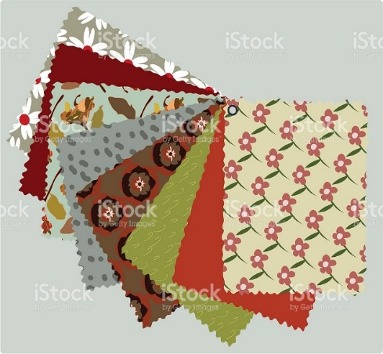 These prints were added after the fabric was woven

**Embossing** is the use of an engraved roller to create a permanent 3D effect

**Istock id: 505936676**

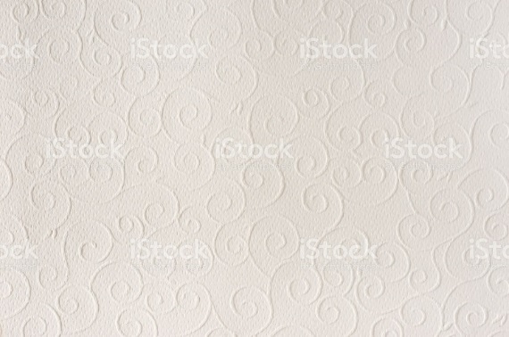 The 3D effect of the swirl pattern is embossed onto the fabric.

**Etching or burnout** applies an acidic compound that burns or etches a fiber to reveal some sheer pattern in a fabric

**Flocking** is a decorative pattern made with small fibers bonded to a fabric.

**Istock id: 92049915**

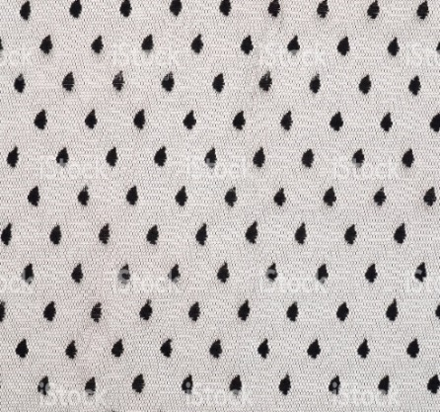 This fabric has a flocked dotted pattern applied.

There are many more kinds of techniques on the market such as heat set, lappet, embroidered, plisse, moiré and more. Doing some research into the world of fabrics can allow you to discover some of these other interesting decorative ways to make fabric.

Patterns:

There are multitudes of patterns on today’s market in fabrics for us to choose from. Most of the public do not get to see all the patterns available that decorators can choose from. The selection seems almost endless in style, colour combination and pattern choices so that a decorator can select and create a one of a kind treatment for their client. It can be very exciting to see an array of materials from low to high price points that are on the market. There is something for everyone at every budget and in every fabric content. I am pointing out a few here that are ones you should be able to recognize and be able to identify. If you have the chance to visit a drapery shop, take some time to browse through the fabric selections they have and see how exciting and beautiful some of the choices are.

**Interesting note:** Over the past decade not as many patterns have been used with contemporary design styles. Often it is texture that has been used mostly in this style of décor with the odd pattern added. You will see a change in this happen over the next decade with pattern making more of a comeback as we soften the rectilinear lines of the last decade. You are seeing it now in home décor with crystals, shiny silver and gold surfaces and more curved lines creeping into our décor.

**Stripe**

Istock id: 183581963

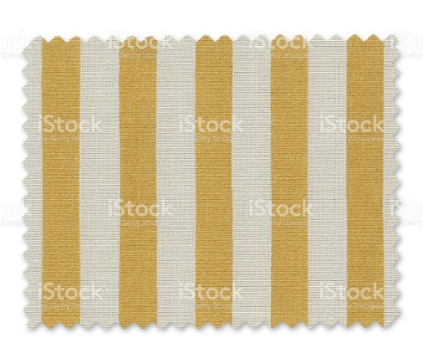Stripes can be wide or narrow, vertical or horizontal but are always timeless for all styles. When in doubt about what kind of pattern will not go out of date, choose a stripe.

**Roman stripe**

Istock id: 460682565

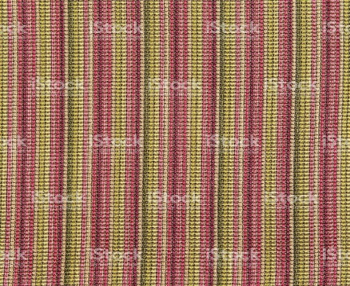 A roman stripe is one with multi colours in the fabric. Any colour combination can be used and for any style of window treatment. Like all stripes they are rather timeless patterns and only the colour combination will change style.

**Plaid**

Istock id: 531058036

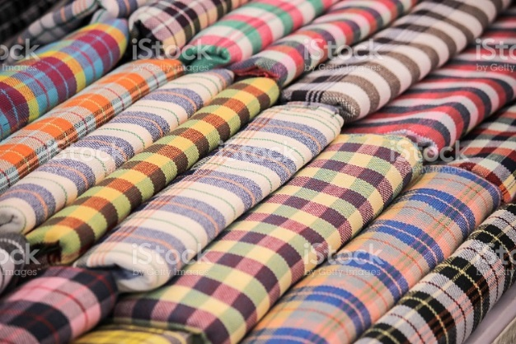 Plaids can come in many colours and styles from small to large sizes. Like a stripe they can be quite timeless from country ginghams to sophisticated silk prints for traditional and even modern uses.

**Chevron**

Istock id: 645186374

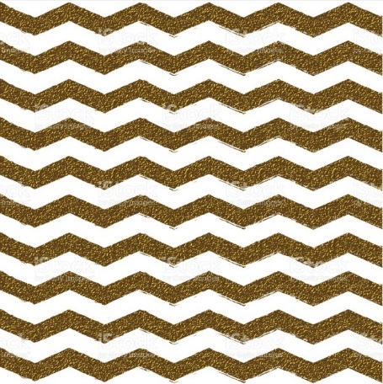 This chevron pattern depicts these zig-zag lines like chevrons seen on highways.

**Harlequin**

Istock id: 645186500

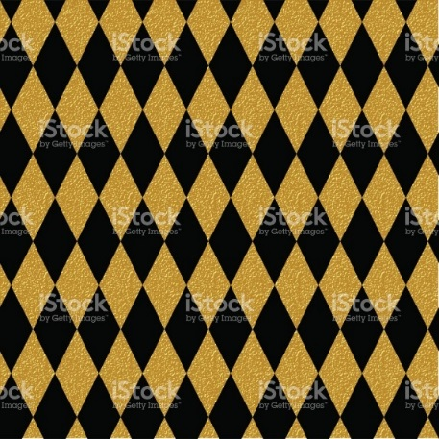 Harlequin is the term for a fabric that has this kind of diamond pattern. It is a geometric that can be used in many colour combinations and for all styles of window treatments.

**Geometric**

Istock id: 601945190

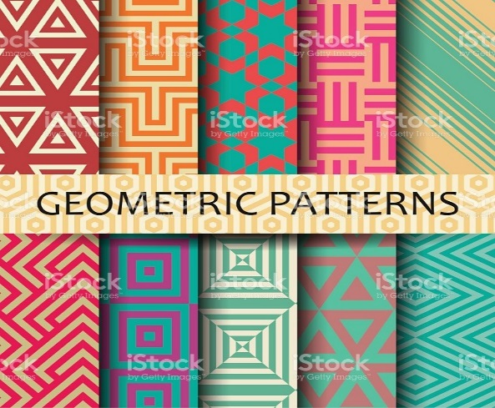 Geometrics include stripes, plaids, diamonds, chevrons and circles. They are timeless and used in all styles of decorating for window treatments. They mix well with floral patterns.

**Floral**

Istock id: 153164932

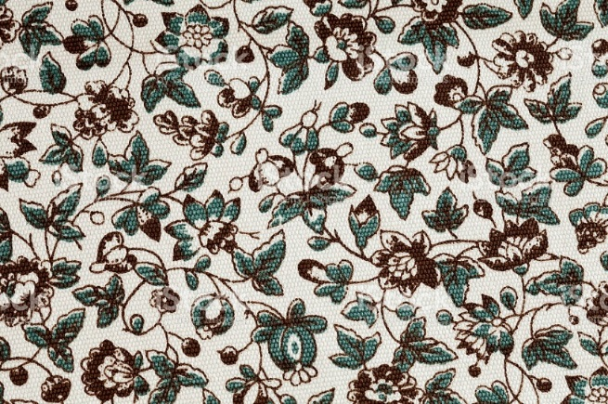 Floral patterns can be designed to suit any style from traditional to country to even contemporary. They are often used in window treatments and upholstery.

**Toile de Jouy**

Istock id: 165771518

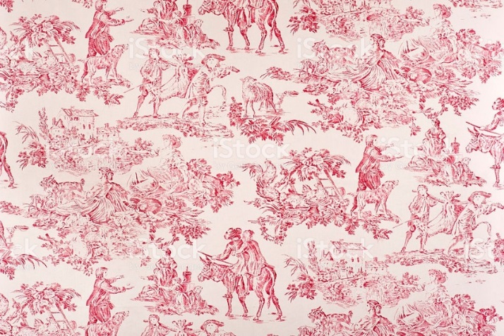 Toile de Jouy is a fabric with one or sometimes two colours depicting a French country scene of people and animals. It is usually thought of as a traditional or Country French pattern used for window treatments, upholstery and sometimes wall coverings. Usually made from linen or cotton, they can be found in some blended yarn uses as well.

**Paisley**

Istock id: 119599692

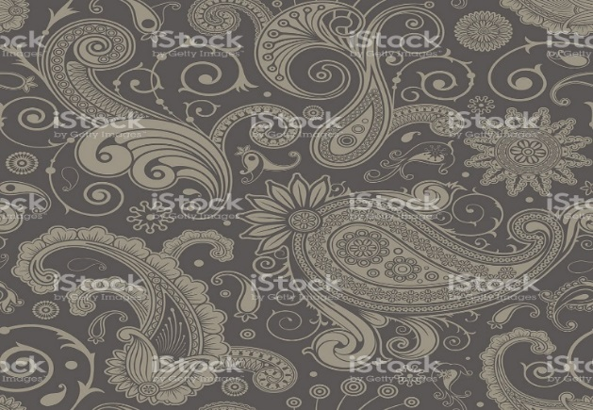 Paisley is a swirl pattern that often is a dense print covering a fabric surface. It can come in many colours and sizes that has a lot of movement in the pattern appearance.

**Contemporary**

Istock id:

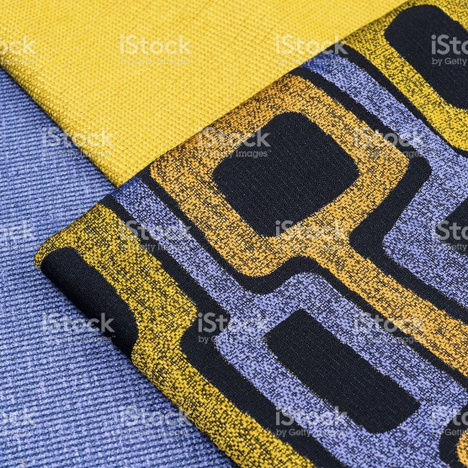Contemporary prints can range from abstract to geometric to stylized floral patterns.

### Mixing fabrics in one treatment:

A window treatment does not have to be just one fabric. Using more than one fabric in the same treatment can make for a more interesting finished look in some cases. Many patterns can work well together.

Did you know you can use two florals together? Well it is true! When mixing florals you just need to keep in mind that the florals need to be different scales. If one floral is about the size of your fist, you can select another floral that is much smaller or much larger than that one to mix together.

Geometrics can be mixed with most florals easily as long as they relate in colour, texture and style. For example a stripe can be mixed with almost any other pattern. A plaid can add a great pattern to a plain or print.

You likely have seen many treatments that have 2 solid colours together, often on the bottom of a treatment or down the sides. This is a great way to add length to a treatment you already have. Check out some window treatment books to get ideas of how you can combine fabric patterns to make a one of a kind look for a window. The options offer endless ideas to make a treatment unique and interesting. Think of adding a band of a different pattern or colour to a treatment…

Istock id: 461299393

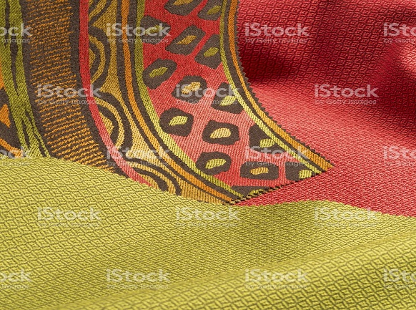 The multi-colour pattern shown here can be mixed with any fabric in one or more of the colours.

Istock id: 185254530

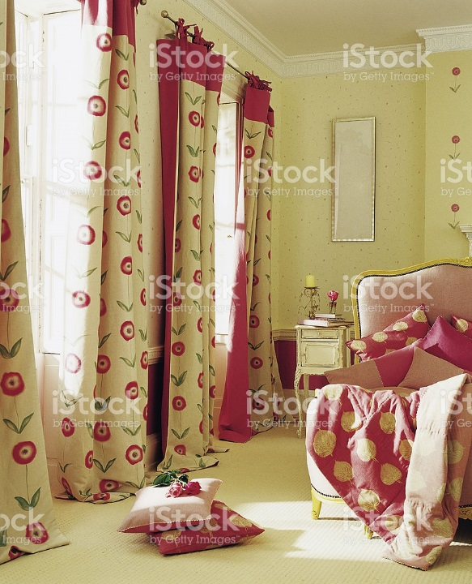 This fun treatment has a plain and a pattern combination but you could have also made the plain a stripe, plaid or other print as well.

Fabric weights**:**

Fabrics do not all have the same weight or density. When planning window treatments it is important to consider how the fabric you select will work for a particular window design. Will the fabric drape well? Will it be too stiff or too soft? Selecting an appropriate weight of fabric is critical to the success of the treatment when completed. Fabrics come in three basic weights; heavy, medium and light. Weight does not mean that one is better than the other for quality or price, but just better for some treatments than others. Most upholstery fabrics are heavy weight because they are thicker kinds of fabric. Fabric sample books from manufacturers will list the uses and state if they are suitable for upholstery, window treatments and or bedding. All weights can give you a beautiful end result to suit the look and style you are wanting to achieve.

**Heavy** weight fabrics like leather, tapestry, some thick velvets, brocade and denim can be very heavy to hang on a rod, do not open and close easily and will not drape and pleat like some other weights will. These weights are good for more structured treatments like upholstered valances, swag treatments or lambrequins where they can be stapled into a fixed place. Drapery that is stationary can also work if the fabric drapes well enough so that it will not be too heavy to open and close on a rod.

Istock id: 481183920

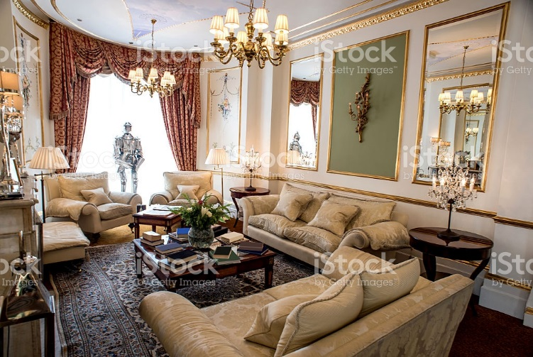 This structured swag and jabot treatment valance is suitable for this space as the treatment does not move and is fixed in place.

**Medium** weight fabrics are very common in window treatments as they are very pliable and adapt to most window treatment options. They can drape well depending on their fiber content, can open and close with more ease. Medium weight fabrics are generally not as stiff as heavy weight fabrics and have a better “hand”. They come in all fibers from natural to synthetic and all blends and some examples are satin, some velvets, and taffeta.

Istock id: 481572928

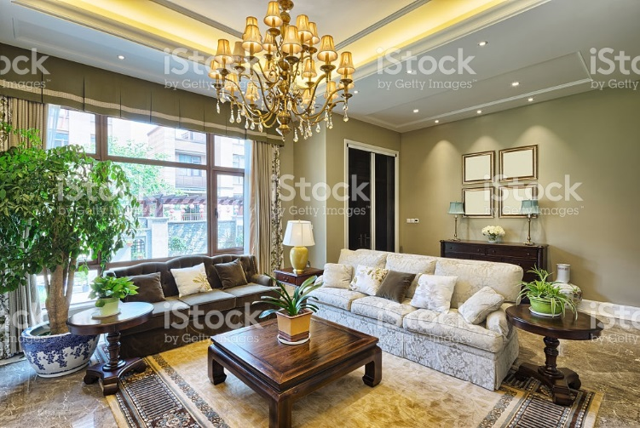This medium weight fabric treatment pleats well and has nice drape on these windows. Notice that it is also using 3 different fabrics on this one window.

**Light** weight fabrics are very soft, flowy and include sheer, lace linen and organza. Often they are see through or semi-sheer though they can be opaque as well. They come from all fabric content sources from natural to synthetic or blended fabrics.

Istock id: 597960556

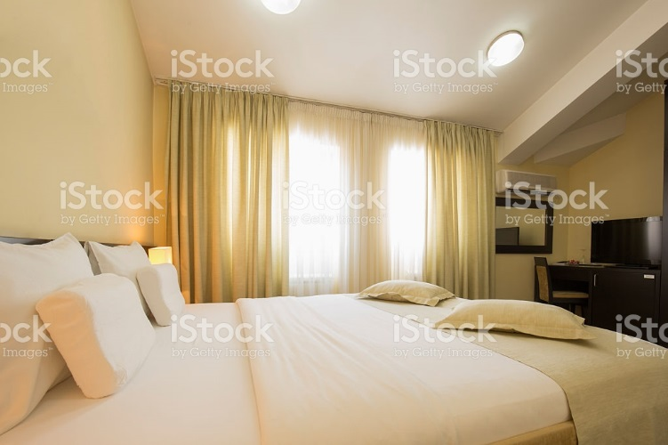 These drapes are very light and soft in appearance and allow light to pass through them into the room.

## Conclusion

You can see that there are many weaves, prints and kinds of fabric for every window treatment look. Several years ago I bought two books called Mary Humphries Reference and Mary Humphries Glossary. The Glossary has 200 fabric swatches that you can put into the book which is a great way to see and feel what each fabric and weave looks like. You may want to consider looking for these if you are interested.

I have been in the window treatment industry for over 20 years and am still learning about fabrics. One of my most favourite things to do is look at fabric samples, feel them and see the colours, patterns and textures on the market. I hope you will be able to do the same as you move through this course and learn to love them as well.

********************* End of instructional content *************************

Evaluation

|  |  |
| --- | --- |
| **Evaluation** | |
| What type of assessment will be included? | Discussion  Written Assignment  Test or Quiz  Individual Project  Group Project  Other. Describe: Click here to enter text. |
| When is the assessment due? | Due the last day of week 5 at 11:55pm |
| How long is the assessment? | This is a research assignment asking the student to research a particular kind of fabric content, weave and pattern supplied by the instructor. They will be required to research the information and supply a photo of each answering question about construction, style, durability etc. on a form provided. Minimum one page for each of 3 sections. |
| What is the weighted value of the assessment? | 10% of final grade |
| List the course learning outcomes for this assessment (number and text). This information must match the Evaluation Matrix. | **CLO02:** Evaluate fabric construction that include weaves, yarns and durability for various window treatment trends. |
| How does the assessment connect with the lesson or the overall goals of the course? | This assignment is putting to use what they have learned this week and to recognize certain weaves, pattern, and fabric content and fabric weight. |
| Instructions | Fabric Assignment #1 due week 5.   * This is a research assignment so you can learn more about different fabrics. * You are required to find the following and take a close up photo of each item that you could use for a window treatment. * You are to find the actual fabric from a fabric store or window treatment store (not photos from on line). * Using at least 1 page for each of the 3 sections answer in detail the questions for each category in as much detail as you can. * You can research each category on line for information. Each fabric must be found on the fabric you find in person. * Scan and add a photo no larger than ¼ of the page in colour * Place your name of the pages * Submit to the drop box provided week 5 * Grade = 10%   Find the 3 following categories…  **1. A natural or synthetic fabric for window treatments.**   * Name the fabric content or blend and state the pros and cons of using this kind of fabric * Is it light, medium or heavy weight * If there is a pattern can you name it? * What kind of window treatments would you want to use this on? Describe   **2. Select one of the following: Moiré, taffeta, brocade, lace, Organza**   * Give a description of the fabric * What kind of weave is it? * What is the fabric content? * Is it a light, medium or heavy weight?   **3. Ultra-suede**   * What is the fabric content? * What are the pros and cons of this material? * What kind of weave is this fabric? * Is it a light, medium or heavy weight? |
| Rubric or Marking Scheme | Use this area to explain how the assignment will be assessed or indicate the file name for the rubric.  Click here to enter text.   |  |  |  |  |  | | --- | --- | --- | --- | --- | | **Rubrics:** |  |  |  |  | | **FABRIC #1 Assignment** | **Distinguished** | **Good** | **Acceptable** | **Developing** | | **Content** | Assignment written in excellent detail describing all required information in detail.  Research related to assignment and appropriate relation to window treatments | Assignment written in good detail describing most of required information.  Research related to assignment and appropriate relation to window treatments. | Assignment was lacking some detail describing most of required information.  Research lacked some relation to assignment and relation to window treatments. | Assignment had poor detail resulting in a lack of information that would have properly described the relation to the assignment and relation to window treatments. | | **Accuracy** | Information provided was accurate and relevant to the subject matter with no spelling or grammatical errors.  Photo was accurate and correct size on page.  Name placed on the page | Information provided was mostly accurate and relevant to the subject matter with one spelling or grammatical errors.  Photo was accurate and correct size on page.  Name placed on the page | Information lacked some accuracy and relevancy to the subject matter.  More than one spelling or grammatical error.  Photo was correct size and accurate depiction.  Name placed on the page | Information lacked accuracy and relevancy to the subject matter.  Multiple spelling and or grammatical errors.  Photo was incorrect size and or accurate depiction.  Name not placed on the page. | | **Communicates clearly** | Information was easy to read and understand with excellent organization of data.  Interesting to read and provided clear explanation in an appropriate manner. | Information was easy to read and understand with good organization of data.  Lacked some interest to read and provide a clear explanation of information. | Information was somewhat easy to read and understand, yet organization of data could be improved to communicate more clearly to explain information to the reader. | Information was difficult to read and understand.  Lack of organization and little interest in the information made it difficult to understand the explanation and information provided. | | **Overall Score** | Distinguished  20 points | Good  16 or more points | Acceptable  10 or more points | Developing  0-4 points |   We need a drop box week 5 for this assignment |